WEEK 4 STATUS REPORT
Project Title:
High Availability Router Project using HSRP and GNS3.
Course:
Computer Networks Lab
Submitted To:
Sir Muhammad Fahad Irshad
Submitted By: (Group 6)
- Sumaiya Bibi F2024266340
- Rameen Junaid F2024266341
- Tayyba Shahzad F2024266348
- Eshmal Zahid F2024266755
Introduction:
This project aims to design and implement a High Availability Router network using GNS3. The network consists of routers, a switch, end devices, and a Kali Linux machine. The objective of Week 2 was to implement the designed topology, configure devices, establish network connectivity, and verify secure remote access through SSH.
Objective:
The objective of this week was to verify HSRP functionality, perform failover and recovery testing, validate network security controls, and evaluate overall network performance.
NAT Verification:
NAT is not applicable in this project because all devices operate within a single private LAN and no Internet connectivity is required.

HSRP Verification:
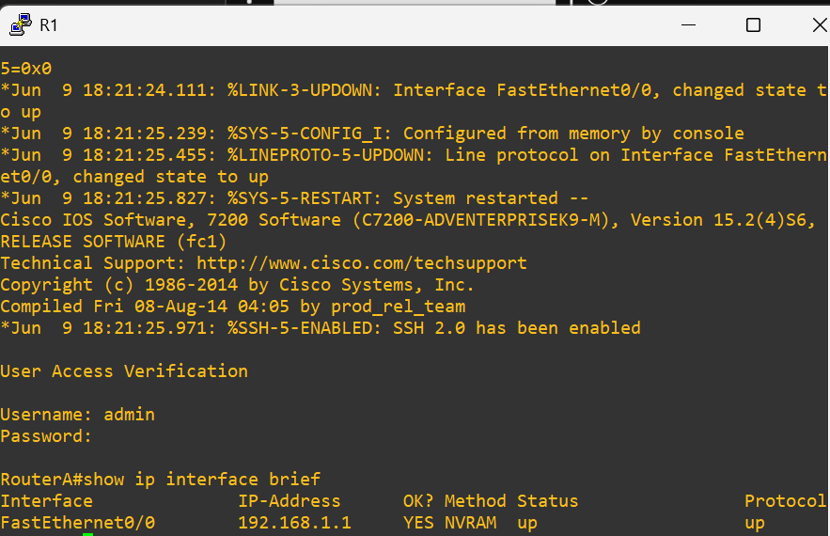
RouterA was configured as the Active router and RouterB was configured as the Standby router. HSRP status was verified successfully before testing.
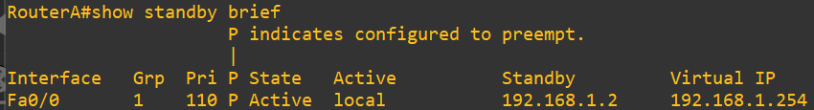

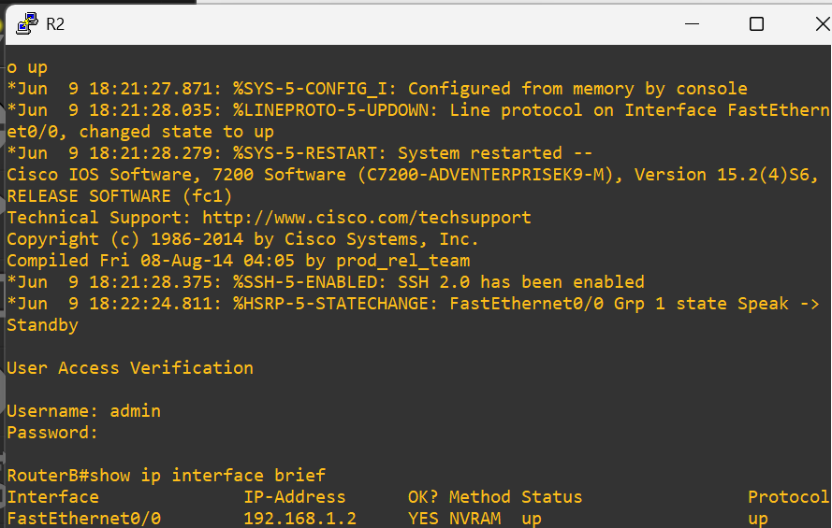

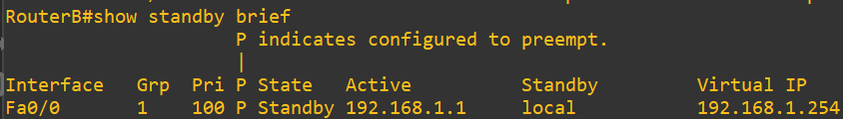

Switch Verification:
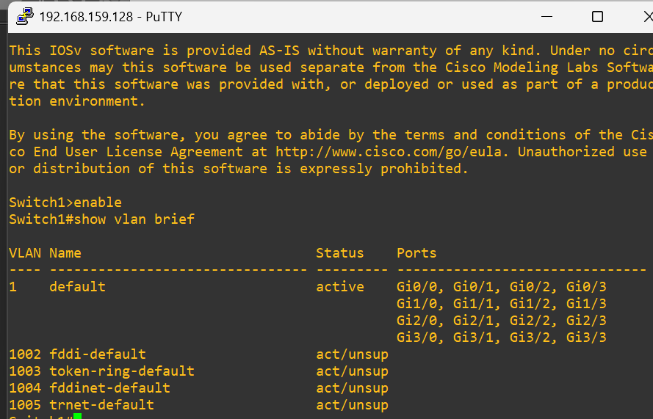
The switch configuration and VLAN information were verified successfully.

Security Verification:
ACL configuration was verified to ensure that security policies were properly implemented on the network.
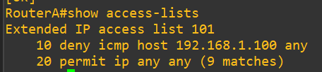
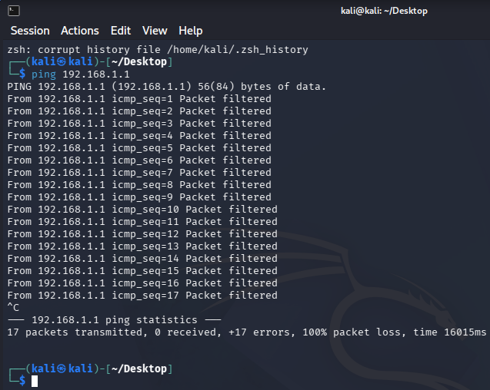
A security test was performed from Kali Linux. The ACL successfully filtered unauthorized traffic according to the configured rules.

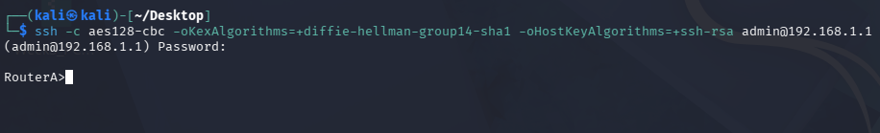
SSH configuration was verified and secure remote management was enabled on the router.

Connectivity Testing:
The following connectivity tests were performed successfully:
• PC1 to Virtual IP (192.168.1.254) – PASS
• PC2 to Virtual IP (192.168.1.254) – PASS
• PC1 to PC2 Communication – PASS
• PC2 to PC1 Communication – PASS
Failover Testing:
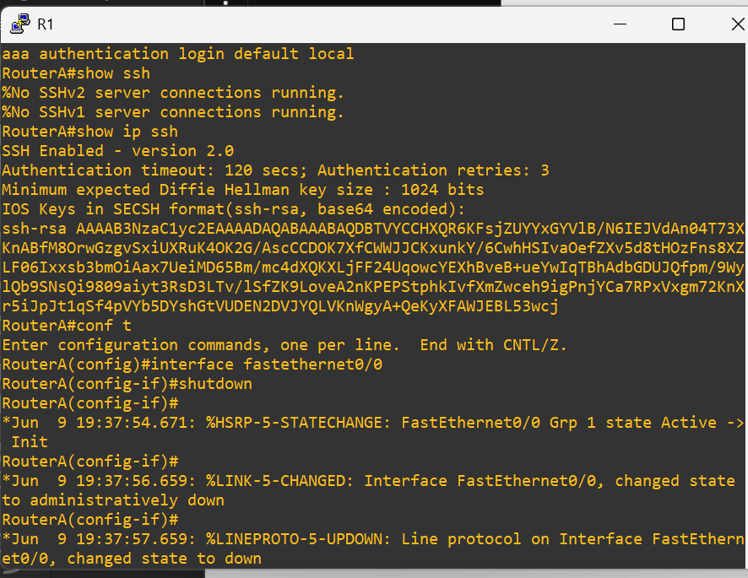
A continuous ping was initiated to the Virtual IP address. RouterA was temporarily shut down to simulate a failure condition.

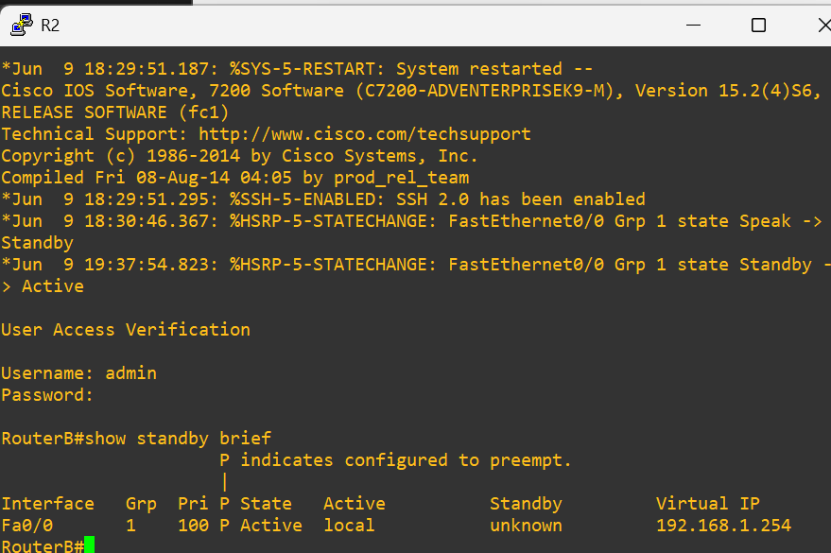
RouterB automatically transitioned from Standby state to Active state and continued providing gateway services.

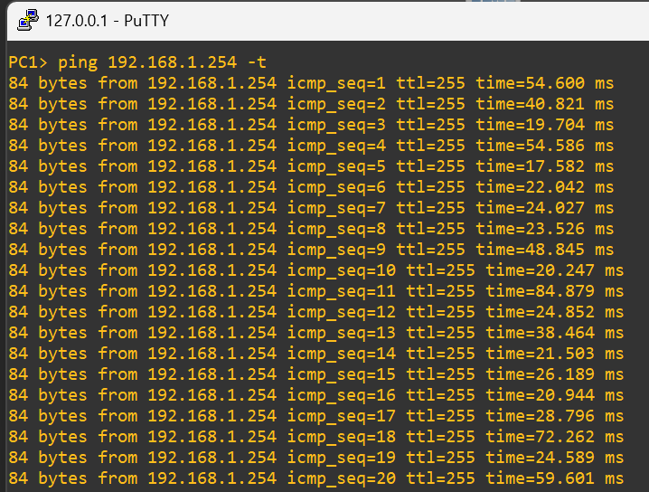
The continuous ping remained operational with minimal packet loss, confirming successful failover.

Recovery Testing:
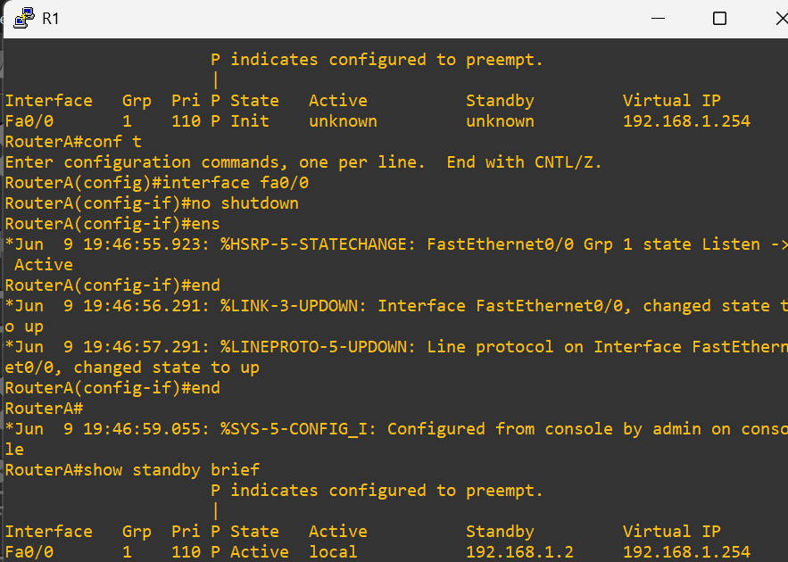
RouterA was restored and resumed the Active role due to HSRP preemption. RouterB returned to the Standby state.

Performance Results:
Average latency remained approximately 35 ms during testing. Network throughput remained stable during failover testing with no significant interruption in connectivity.
Testing Results:
PC1 to VIP: PASS
PC2 to VIP: PASS
PC1 to PC2: PASS
PC2 to PC1: PASS
Failover: PAS
Recovery: PASS
ACL: PASS
SSH Configuration: PASS
Conclusion:
The HSRP-based high availability network was successfully implemented and tested. Security controls, failover mechanisms, recovery procedures, and connectivity validation were completed successfully. The network maintained stable performance throughout testing.

